Hands-on 1: Create a Spring Web Project using Maven

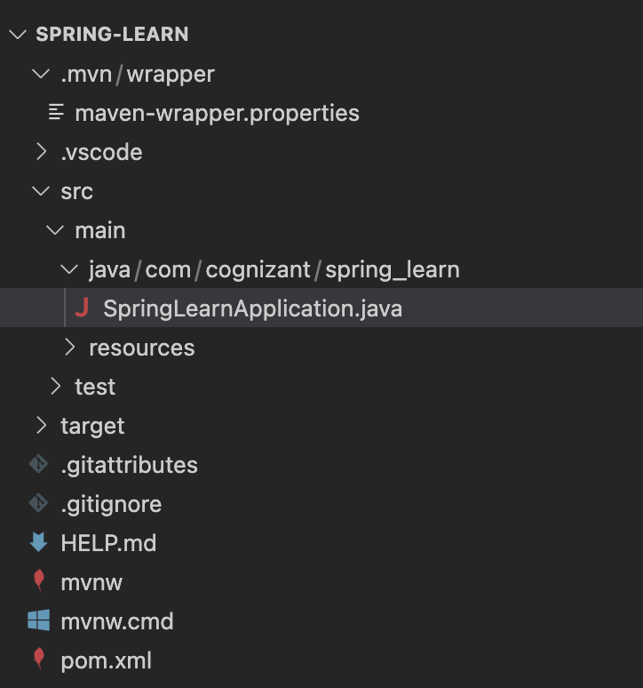
SpringLearnApplication.java:
package com.cognizant.spring_learn;

public class SpringLearnApplication {

public static void main(String[] args) {
System.out.println("SpringLearnApplication has started.");
System.out.println("Simulating Spring Boot project structure in plain Java.");
System.out.println("This would normally launch Spring Boot context with @SpringBootApplication.");
}
}

Output:
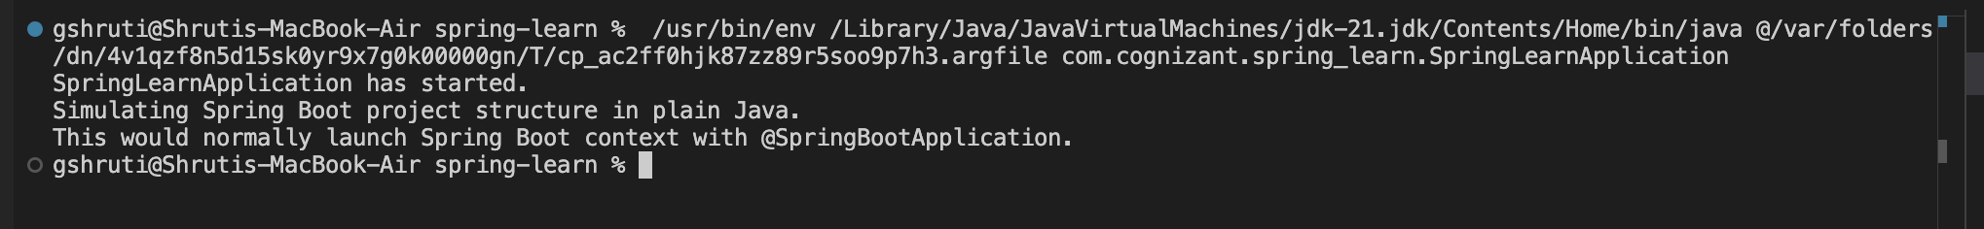

Hands-on 2: Spring Core – Load SimpleDateFormat from Spring Configuration XML
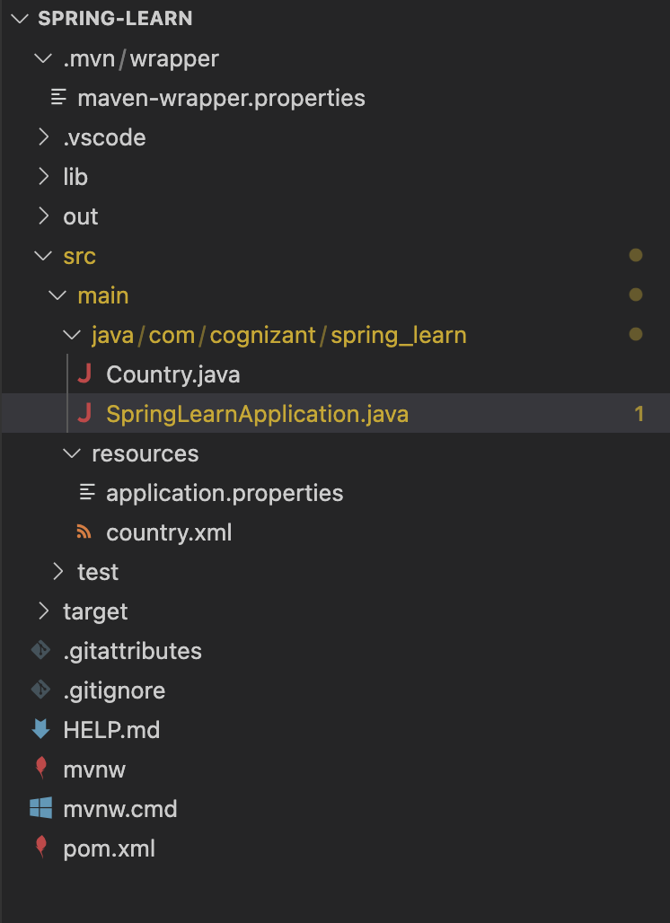
Country.java:
package com.cognizant.spring_learn;

public class Country {
private String code;
private String name;

public Country() {
System.out.println("Inside Country Constructor.");
}

public String getCode() {
System.out.println("Inside getCode()");
return code;
}

public void setCode(String code) {
System.out.println("Inside setCode()");
this.code = code;
}

public String getName() {
System.out.println("Inside getName()");
return name;
}

public void setName(String name) {
System.out.println("Inside setName()");
this.name = name;
}

@Override
public String toString() {
return "Country [code=" + code + ", name=" + name + "]";
}
}

SpringLearnApplication.java:
package com.cognizant.spring_learn;

import org.springframework.context.ApplicationContext;
import org.springframework.context.support.ClassPathXmlApplicationContext;

public class SpringLearnApplication {
public static void main(String[] args) {
System.out.println("SpringLearnApplication has started.");
displayCountry();
}

public static void displayCountry() {
ApplicationContext context = new ClassPathXmlApplicationContext("country.xml");
Country country = context.getBean("country", Country.class);
System.out.println("Country : " + country.toString());
}
}

country.xml:
<?xml version="1.0" encoding="UTF-8"?>
<beans xmlns="http://www.springframework.org/schema/beans"
xmlns:xsi="http://www.w3.org/2001/XMLSchema-instance"
xsi:schemaLocation="
http://www.springframework.org/schema/beans
https://www.springframework.org/schema/beans/spring-beans.xsd">

<bean id="country" class="com.cognizant.spring_learn.Country">
<property name="code" value="IN" />
<property name="name" value="India" />
</bean>
</beans>

Output:
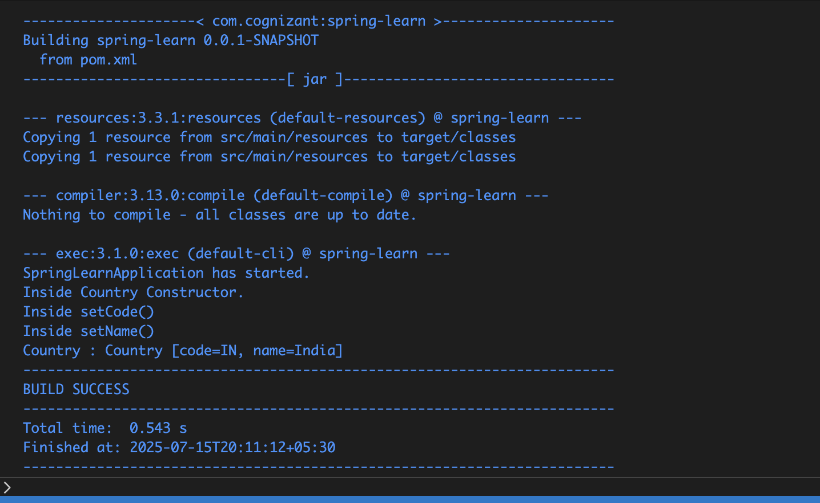

Hands-on 3: Hello World RESTful Web Service
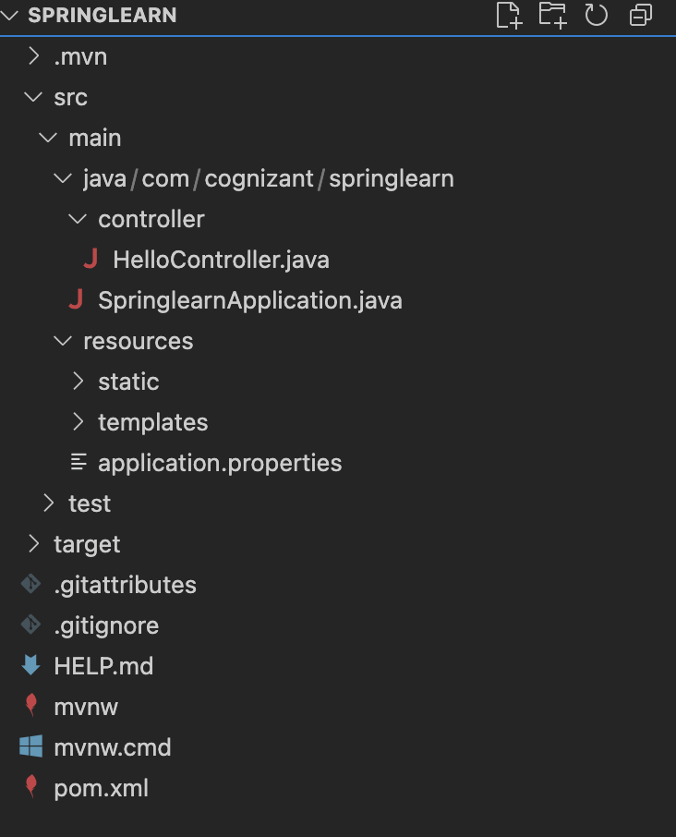

HelloController.java:
package com.cognizant.springlearn.controller;
import org.slf4j.Logger;
import org.slf4j.LoggerFactory;
import org.springframework.web.bind.annotation.GetMapping;
import org.springframework.web.bind.annotation.RestController;

@RestController
public class HelloController {
private static final Logger LOGGER = LoggerFactory.getLogger(HelloController.class);
@GetMapping("/hello")
public String sayHello() {
LOGGER.info("Start");
LOGGER.info("End");
return "Hello World!!";
}
}

SpringLearnApplication.java:

package com.cognizant.springlearn;
import org.springframework.boot.SpringApplication;
import org.springframework.boot.autoconfigure.SpringBootApplication;

@SpringBootApplication
public class SpringlearnApplication {
public static void main(String[] args) {
SpringApplication.run(SpringlearnApplication.class, args);
}
}

Application.properties:

server.port=8083

Output:
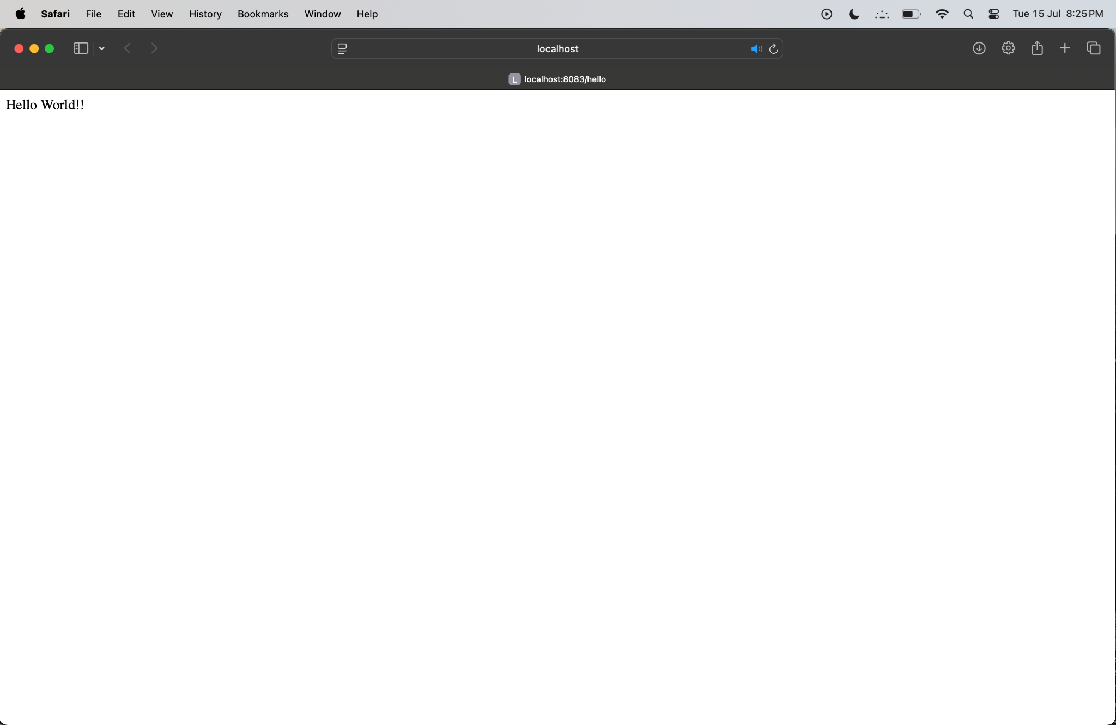

Hands-on 4: REST - Country Web Service

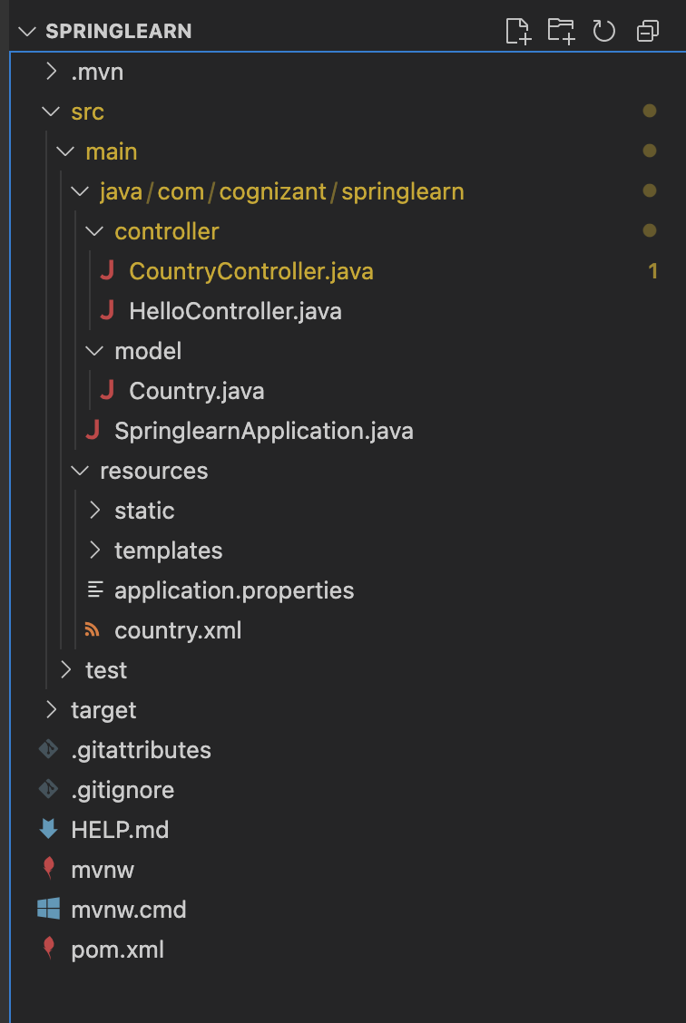
Country.java:
package com.cognizant.springlearn.model;
public class Country {
private String code;
private String name;
public Country() {
System.out.println("Inside Country Constructor.");
}
public String getCode() {
System.out.println("Inside getCode");
return code;
}
public void setCode(String code) {
System.out.println("Inside setCode");
this.code = code;
}
public String getName() {
System.out.println("Inside getName");
return name;
}
public void setName(String name) {
System.out.println("Inside setName");
this.name = name;
}
@Override
public String toString() {
return "Country [code=" + code + ", name=" + name + "]";
}
}

country.xml:
<?xml version="1.0" encoding="UTF-8"?>
<beans xmlns="http://www.springframework.org/schema/beans"
xmlns:xsi="http://www.w3.org/2001/XMLSchema-instance"
xsi:schemaLocation="http://www.springframework.org/schema/beans
https://www.springframework.org/schema/beans/spring-beans.xsd">
<bean id="country" class="com.cognizant.springlearn.model.Country">
<property name="code" value="IN"/>
<property name="name" value="India"/>
</bean>
</beans>

CountryController.java:
package com.cognizant.springlearn.controller;
import org.springframework.context.ApplicationContext;
import org.springframework.context.support.ClassPathXmlApplicationContext;
import org.springframework.web.bind.annotation.RequestMapping;
import org.springframework.web.bind.annotation.RestController;
import com.cognizant.springlearn.model.Country;
@RestController
public class CountryController {
@RequestMapping("/country")
public Country getCountryIndia() {
ApplicationContext context = new ClassPathXmlApplicationContext("country.xml");
Country country = (Country) context.getBean("country");
return country;
}
}

Output:
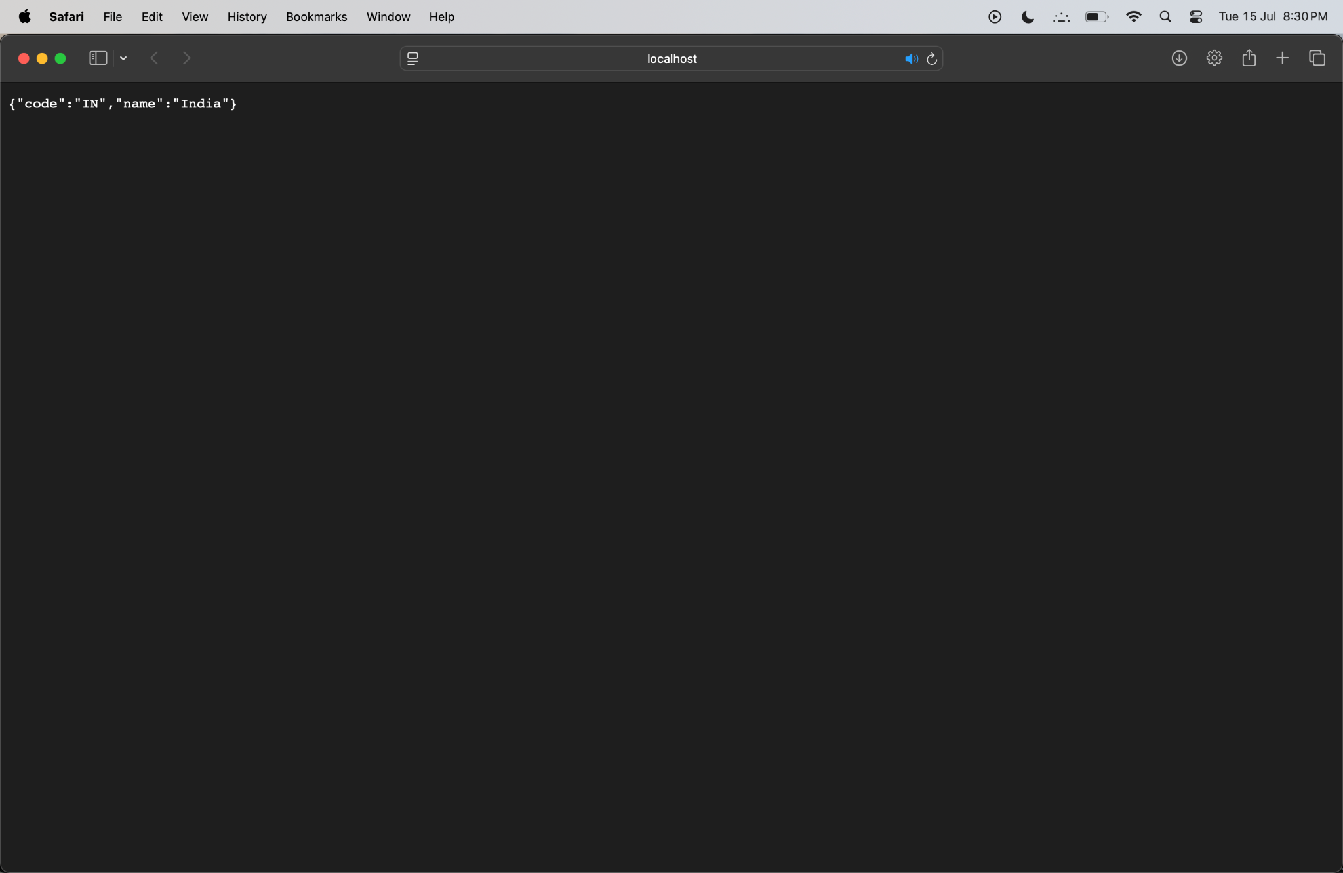

Hands-On 5: Get country based on country code

CountryService.java:
package com.cognizant.springlearn.service;
import java.util.List;
import org.springframework.context.ApplicationContext;
import org.springframework.context.support.ClassPathXmlApplicationContext;
import org.springframework.stereotype.Service;
import com.cognizant.springlearn.model.Country;

@Service
public class CountryService {
public Country getCountry(String code) {
ApplicationContext context = new ClassPathXmlApplicationContext("country.xml");
List<Country> countries = context.getBean("countryList", List.class);

return countries.stream()
.filter(country -> country.getCode().equalsIgnoreCase(code))
.findFirst()
.orElse(null);
}
}

Output:
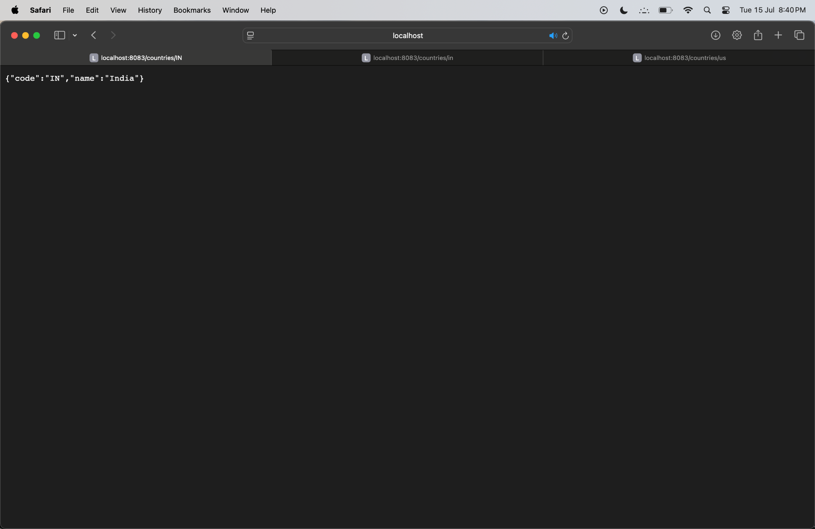

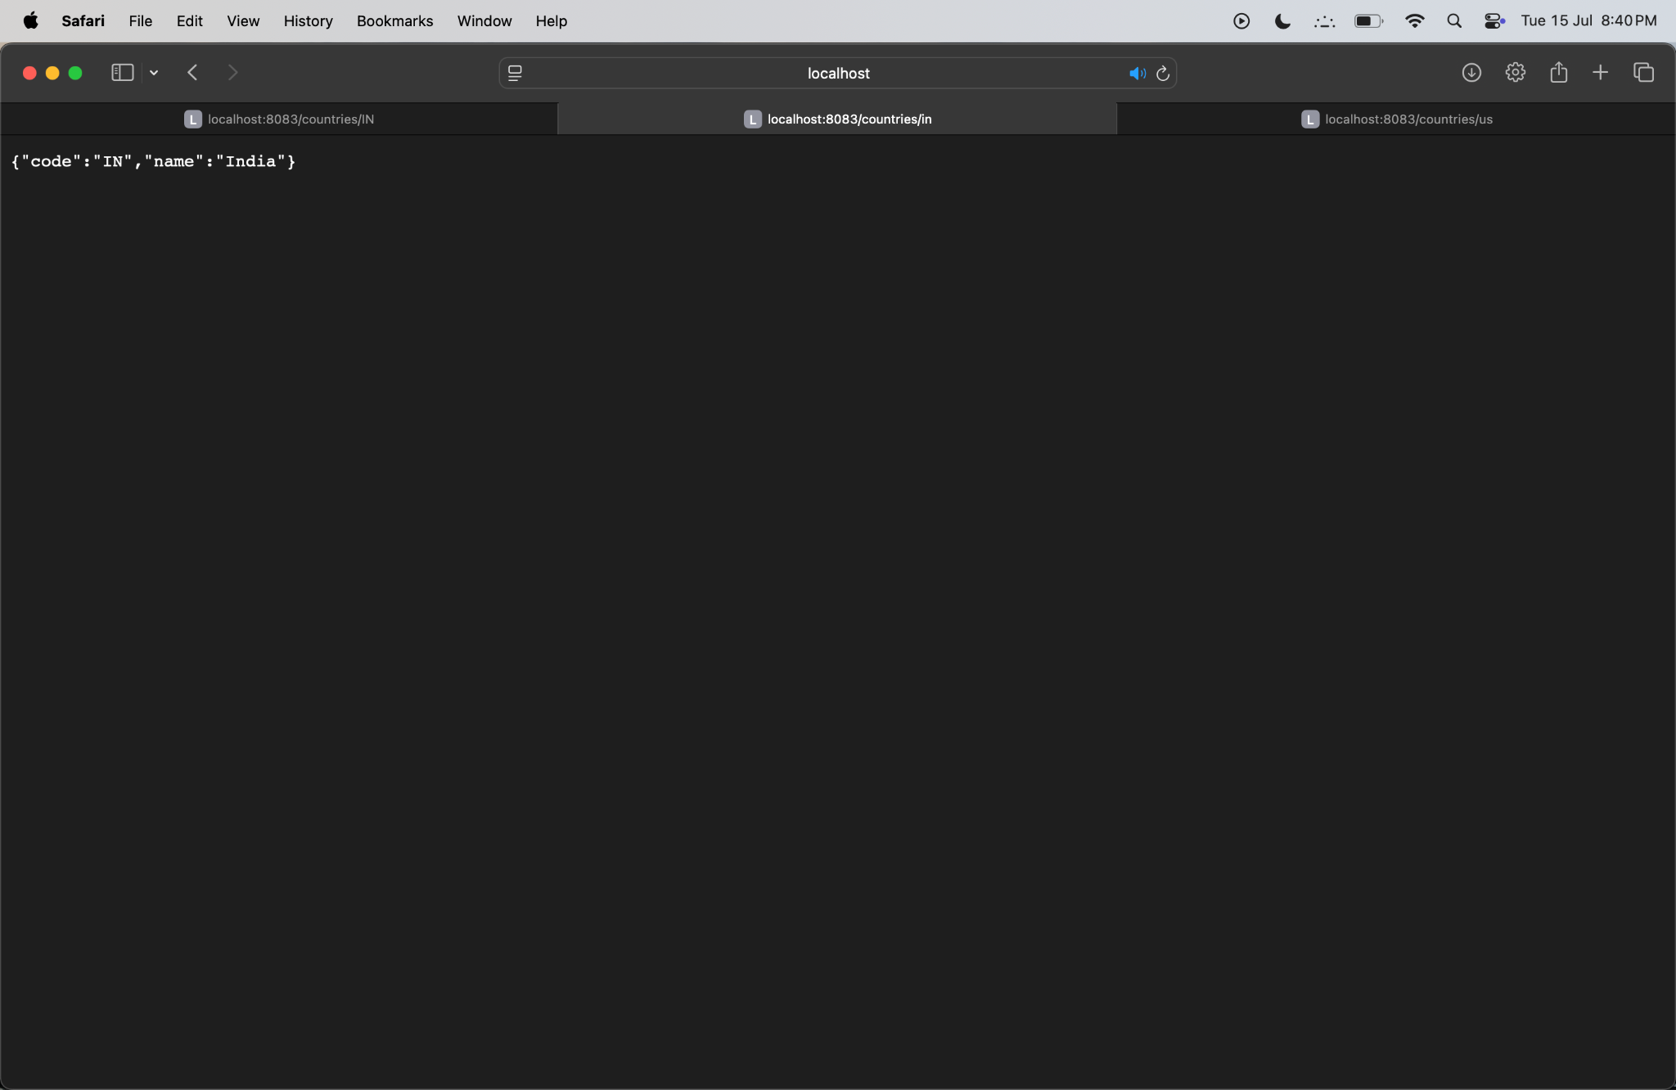
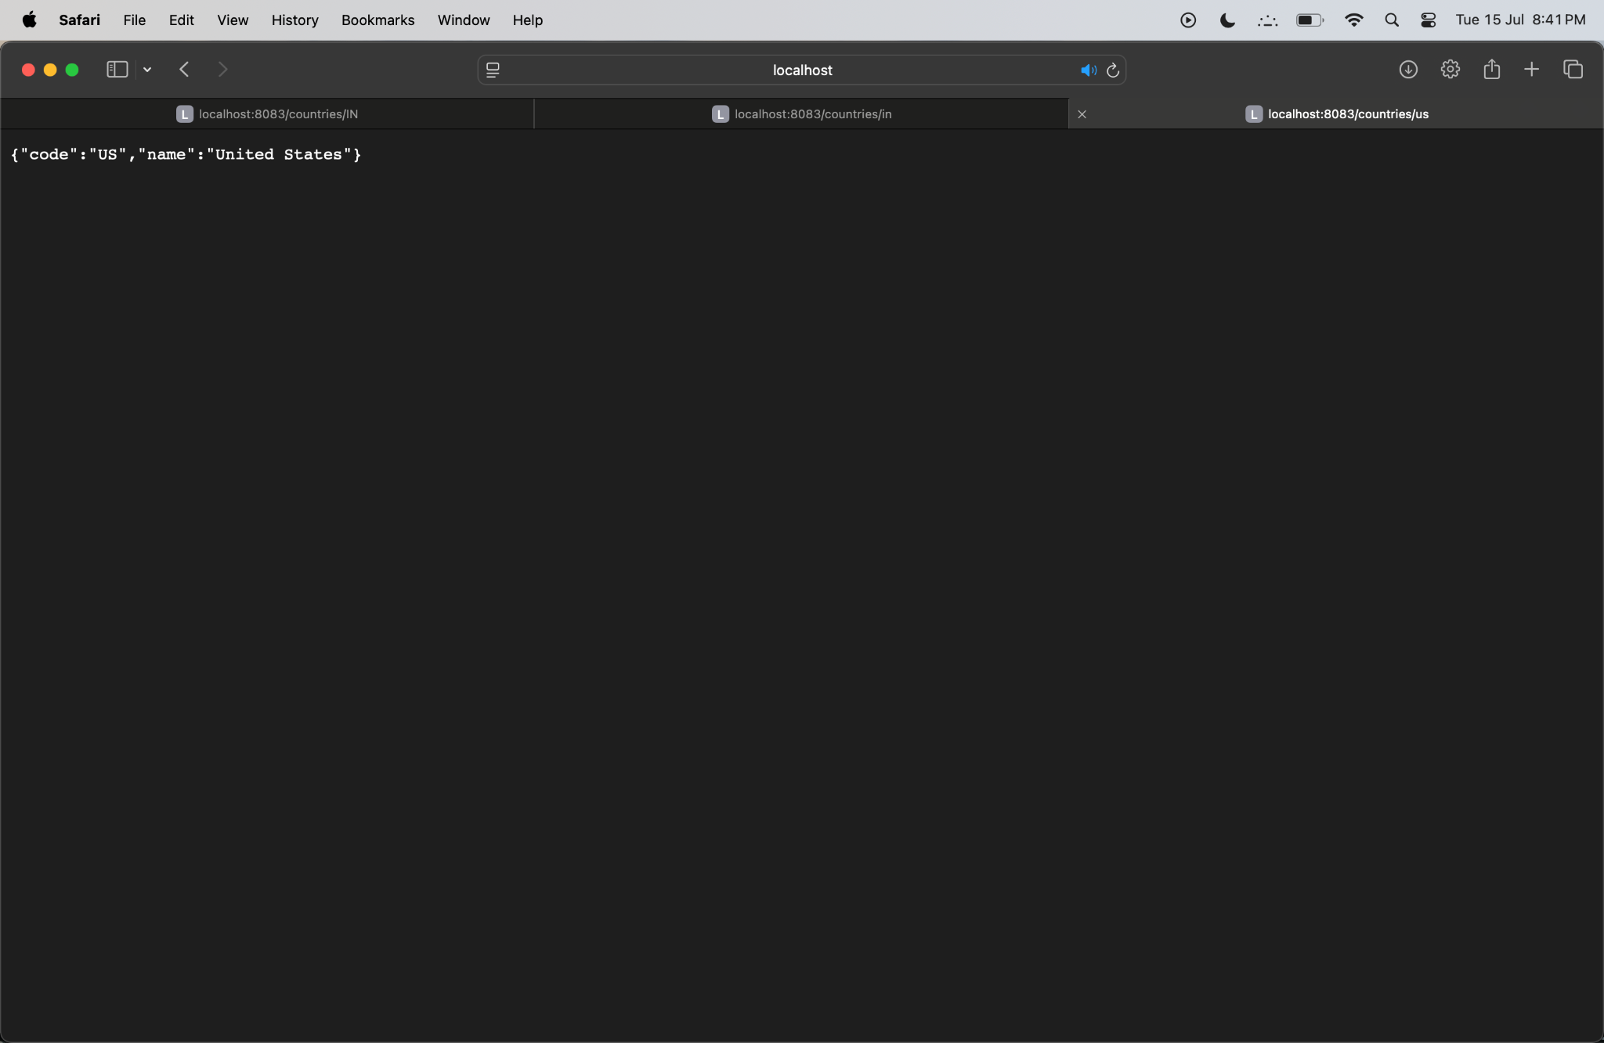

Hands-on 6: Create authentication service that returns JWT
SecurityConfig.java:
package com.cognizant.jwt.config;
import org.springframework.context.annotation.Bean;
import org.springframework.security.config.annotation.web.builders.HttpSecurity;
import org.springframework.security.web.SecurityFilterChain;
import org.springframework.context.annotation.Configuration;
@Configuration
public class SecurityConfig {

@Bean
public SecurityFilterChain filterChain(HttpSecurity http) throws Exception {
http
.authorizeHttpRequests(auth -> auth
.requestMatchers("/authenticate").authenticated() .anyRequest().permitAll()
)
.httpBasic() .and()
.csrf().disable(); return http.build();
}
}

AuthController.java:

package com.cognizant.jwt.controller;

import org.springframework.web.bind.annotation.*;
import org.springframework.http.ResponseEntity;
import org.springframework.security.core.Authentication;
import org.springframework.security.core.context.SecurityContextHolder;

@RestController
public class AuthController {

@GetMapping("/authenticate")
public ResponseEntity<?> authenticateUser() {
Authentication auth = SecurityContextHolder.getContext().getAuthentication();
String username = auth.getName();

String token = "token-for-user-" + username;
return ResponseEntity.ok("{\"token\":\"" + token + "\"}");
}
}

Application.properties:
server.port=8090

spring.security.user.name=user
spring.security.user.password=pwd

Output: 